2023 Explore Retirement Living
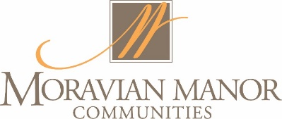

A few tips to ensure you have any enjoyable experience while visiting our campuses!

- OPEN FOR TOURING – The homes that are open for touring are indicated on the campus map you received at registration. They are also identified with a Welcome sign along with a mum & balloon.

- PUBLIC RESTROOMS are available in the “Main Building” on the Founders campus and in the Woods apartment building on the Warwick Woodlands campus.

- REFRESHMENTS are available in the Gallery Café on the Founders campus and in the Owl’s Nest on the Warwick Woodlands campus.

- VOLUNTEERS – Resident and Staff volunteers are available on both campuses to help provide direction and answer questions.

- PHOTOS – Please refrain from taking photos of the inside of resident homes.

- BOOTIES – Please remove your shoes or use the provided booties when entering a resident’s home.

- THANK YOU – Thank you for exploring Moravian Manor Communities. We look forward to seeing you again soon.

